**Superbowl Commercial Analysis from 2001 t0 2021**

By Analysis past two decades of Data of different brands commercials data   
I figured out the below insights  
  
  
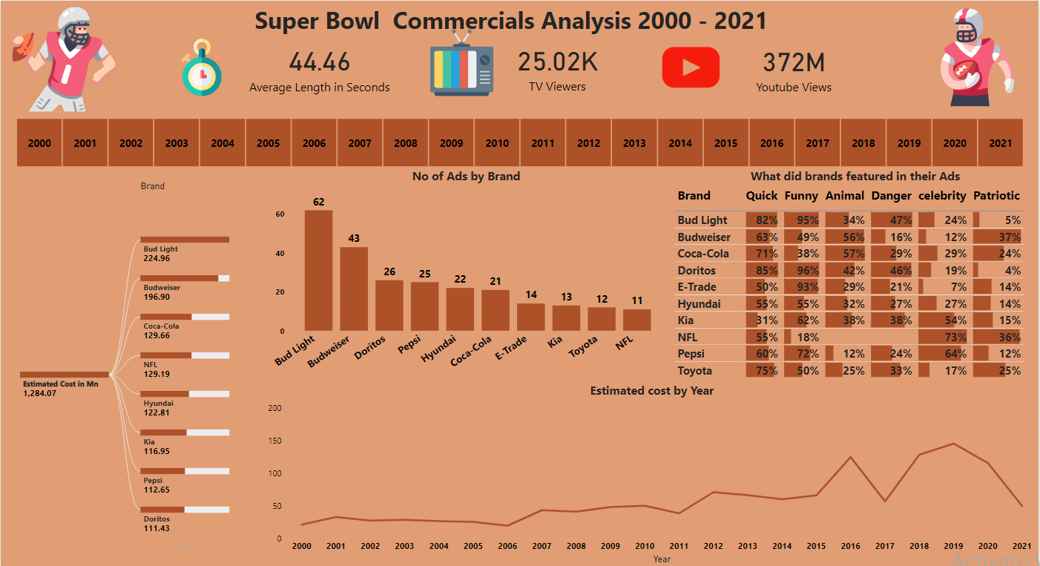

Insights:  
